|  |
| --- |
| **NATIONAL UNIVERSITY OF COMPUTER AND EMERGING SCIENCES**  **DATA STRUCTURES LAB**  **Lab Session 08** |
| **Instructors:** Mr.Irfan , Ms. Mubashra |

**Queue:**

A queue is a particular kind of abstract or collection. In which its insertion and removal routines follows the ﬁrst-in-ﬁrst-out (FIFO) principle.

* First In First Out (FIFO).  Insertions at the "end" of the queue, and removals from the "front" of the queue.
* Analogy - waiting in line for a ride at an amusement park.  Get in line at the end.  First come, first serve.
* A queue class will have two primary operations:
  + **enqueue** -- Elements are inserted at the rear (i.e. at the back of the line)
  + **dequeue** -- removed from the front .
* Typical application areas include print job scheduling, operating systems (process scheduling).

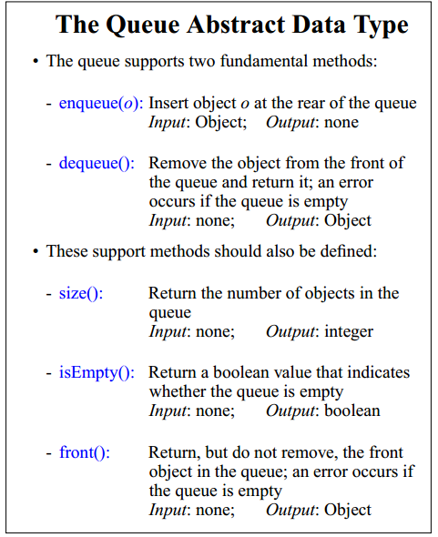

**Task1:**

1. **Create Queue and implement all functions using Singly Linked List.**
2. **Implement a queue which deletes all negative integers without changing the order of the remaining elements in the queue.(u have to use dequeue operation)**
3. **Implement function which reverses the content of queue.**
4. **Implement enqueue and dequeue functions of Queue using Stacks.**

*Algorithm:*

*enQueue(q, x):*

* *While stack1 is not empty, push everything from stack1 to stack2.*
* *Push x to stack1 (assuming size of stacks is unlimited).*
* *Push everything back to stack1.*

*Here time complexity will be O(n)*

*deQueue(q):*

* *If stack1 is empty then error*
* *Pop an item from stack1 and return it*